ASI2 FRC-E-139_PRC_Security_for_action_based_on_responsibility_JAVA_File_Transfer

**Purpose**

FRC-E-139_PRC_Security_for_action_based_on_responsibility_JAVA_File_Transfer

**CCM**  
Requested Production Date 01-Dec-2017  
Scheduled IT Deployment 15-May-2017  
Scheduled UAT Deployment 01-Aug-2017  
Scheduled PROD Deployment 01-Dec-2017

**L2IT**

**Step1:** Take the backup of these files.

|  |  |  |  |
| --- | --- | --- | --- |
| **Main File Name** | **Main File Path** | **Backup File Name** | **Backup File Path** |
| ContractDetailsPG.xml | $OKC_TOP/mds/repository/authoring/webui | ContractDetailsPG.xml_ORA_120.5.12010000.2 | $OKC_TOP/mds/repository/authoring/webui  and  /u01/<sid>/ |
| UpdateContractPG.xml | $OKC_TOP/mds/repository/authoring/webui | UpdateContractPG.xml_ORA_120.5.12010000.8 | $OKC_TOP/mds/repository/authoring/webui  and  /u01/<sid>/ |
| ContractDetailsCO.class | $JAVA_TOP/oracle/apps/okc/repository/authoring/webui | ContractDetailsCO.class_ORA_120.17.12010000.10 | $JAVA_TOP/oracle/apps/okc/repository/authoring/webui  and  /u01/<sid>/ |
| UpdateContractCO.class | $JAVA_TOP/oracle/apps/okc/ repository/authoring/webui | UpdateContractCO.class_ORA_120.11.12010000.16 | $JAVA_TOP/oracle/apps/okc/repository/authoring/webui  and  /u01/<sid>/ |

**Step2:** Create the subdirectory “slcust1/oracle/apps/okc/repository/authoring/webui” inside $JAVA_TOP if it’s not already exists. Set permission level to 775 (Recursive) for all the directories.

cd $JAVA_TOP

mkdir -p slcust1/oracle/apps/okc/repository/authoring/webui

chmod -R 775 slcust1/oracle/apps/okc/repository/authoring/webui

**Step3:** Below mentioned JAVA files can be found in the path $APPL_TOP/slcust1 for each instance. Move the files from this path($APPL_TOP/slcust1) to the below destination directories.

|  |  |
| --- | --- |
| **Destination Path** | **Files to be placed** |
| $JAVA_TOP/slcust1/oracle/apps/okc/repository/authoring/webui | SLCUpdateContractCO.java |
| $JAVA_TOP/slcust1/oracle/apps/okc/repository/authoring/webui | SLCContractDetailsCO.java |

**Step4:** Create 4 more subdirectories based on the 4 responsibility_id found (using below SQL query) inside $JAVA_TOP. Set permission level to 775 (Recursive) for all the directories.

Please note that responsibility_id can be different in different instances.

SELECT responsibility_id, responsibility_name

FROM fnd_responsibility_vl r,

fnd_application a

WHERE a.application_short_name = 'SLCUST1'

AND a.application_id = r.application_id

AND r.responsibility_name IN

('SLCOKC Contract Creation-Consolidated',

'SLCOKC Contract Creation-Canada',

'SLCOKC Contract Mgmt-Consolidated',

'SLCOKC Contract Mgmt-Canada');

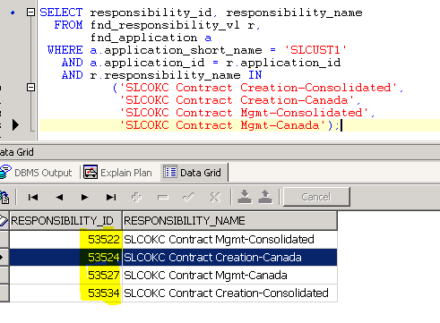

cd $JAVA_TOP

Run below commands 4 times for all the 4 responsibility_id found using above query

mkdir -p slcust1/pers/oracle/apps/okc/repository/authoring/webui/customizations/responsibility/<*resp_id*>

chmod -R 775 sslcust1/pers/oracle/apps/okc/repository/authoring/webui/customizations/responsibility/<*resp_id*>

**(For example:** slcust1/pers/oracle/apps/okc/repository/authoring/webui/customizations/responsibility/53522**)**

**Step5:** Below mentioned XML files can be found in the path $APPL_TOP/slcust1 for each instance. Move the files from this path($APPL_TOP/slcust1) to all the 4 directories created in Step4.

|  |  |
| --- | --- |
| **Destination Path** | **Files to be placed** |
| $JAVA_TOP/slcust1/pers/oracle/apps/okc/repository/authoring/webui/customizations/responsibility/*<resp_id>* | ContractDetailsPG.xml |
| UpdateContractPG.xml |

Repeat Step5 for all the 4 responsibility_id found using above query

**Step6:** Compile the .java files in the same directory using below command:

cd $JAVA_TOP/slcust1/oracle/apps/okc/repository/authoring/webui

javac SLCUpdateContractCO.java

javac SLCContractDetailsCO.java

**Step 7:** Please provide the screenshot of the files to Akshay Nayak (aknayak@deloitte.com)

cd $JAVA_TOP/slcust1/oracle/apps/okc/repository/authoring/webui

ls -lrt SLCUpdateContractCO.java SLCUpdateContractCO.class

ls -lrt SLCContractDetailsCO.java SLCContractDetailsCO.class